BNO055 IMU Documentation

To get fast orientation measurements, we need an IMU to measure roll, pitch, yaw, and their rates. We’re currently using the BNO055 9DOF Sensor, which incorporates a 3DOF accelerometers, gyroscopes, and magnetometers, and automatically fuses their measurements to estimate roll, pitch, yaw, and their rates.

By default, BNO055 is in I2C mode, but this uses a clock-stretching protocol that is not compatible with RPI’s. It may be possible (and even preferable) to circumvent this by controlling the IMU with a microcontroller, but for now, we have adjusted the wiring to put BNO055 in UART mode. To do this, use the following wiring diagram

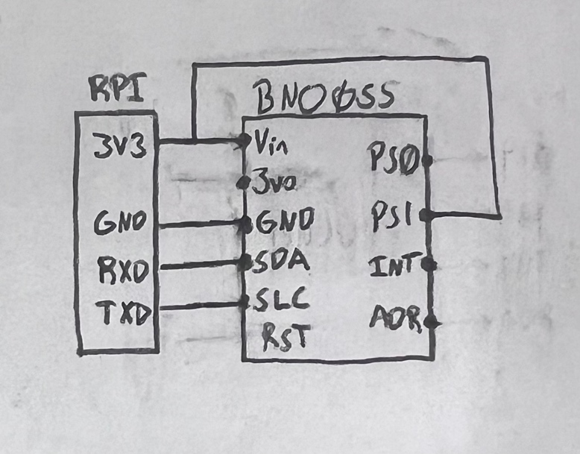

*Note: the BNO sensor was soldered to its pins upside down, so it had to be placed on the underside of the prototyping board. This is very inconvenient. Future versions of the drone should make sure to solder this on top of the board. This may or may not require some adjustments in the code to account for the reorientation of the IMU.*

The python function BNOSensor.py contains three functions pertaining to the IMU

* connectSensor: initializes and configures the BNO
* callibrateSensor: calibrates the sensor. You don’t have to use this every time, just if it gets uncalibrated for some reason. It requires some manual work of moving the drone into different orientations
* getStates: reads the IMU data

The python function Sensors.py contains two functions pertaining to the IMU and Vicon: a function to initialize and a function to read the states. Both call BNOSensor.py functions.